**Enterprise Resource Planning**

**Training User Manual**

**VERSION 12.0.0**

**GENERAL ACCOUNT**

# GENERAL ACCOUNTS

**Options**

• [General Accounts](javascript:run1()&menuname=ac)

• [Master](javascript:run1()&menuname=acmst)

* [Chart of Accounts](http://192.168.1.17:8080/zab/login?screen=acmst&option=Chart+of+Accounts&menuname=acmst)
* [Account Group](http://192.168.1.17:8080/zab/login?screen=achrc1&option=Account+Group&menuname=acmst)
* [Year End Processing](http://192.168.1.17:8080/zab/login?screen=acyearend&option=Year+End+Processing&menuname=acmst)
* [Posting](http://192.168.1.17:8080/zab/login?screen=acpost&option=Posting&menuname=acmst)
* [UnPosting](http://192.168.1.17:8080/zab/login?screen=acunpost&option=UnPosting&menuname=acmst)
* [Posting By Date](http://192.168.1.17:8080/zab/login?screen=acpostdate&option=Posting+By+Date&menuname=acmst)
* [UnPosting By Date](http://192.168.1.17:8080/zab/login?screen=acunpostdate&option=UnPosting+By+Date&menuname=acmst)
* [AC Defaults](http://192.168.1.17:8080/zab/login?screen=acdef&option=AC+Defaults&menuname=acmst)
* [Chart of Account Serial](http://192.168.1.17:8080/zab/login?screen=acgroup&option=Chart+of+Account+Serial&menuname=acmst)

**Same as Codes & Parameter of User Manual Admin**

# Codes & Parameter

|  |  |  |
| --- | --- | --- |
| **Step 1** |  | Open System **>** Administration> Master Setup **>** Codes & Parameter (Open any screen to entry Code) |
| **Step 2** |  | Write Transaction code name & check the Activate box. Write number , Increment & Fill other fields if required. |
| **Step 3** |  | Click **Add** |
| **Result** |  | New Code entry |

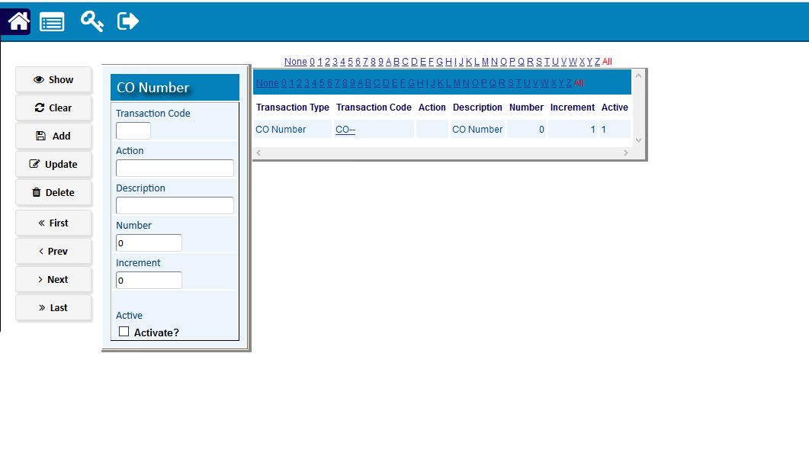

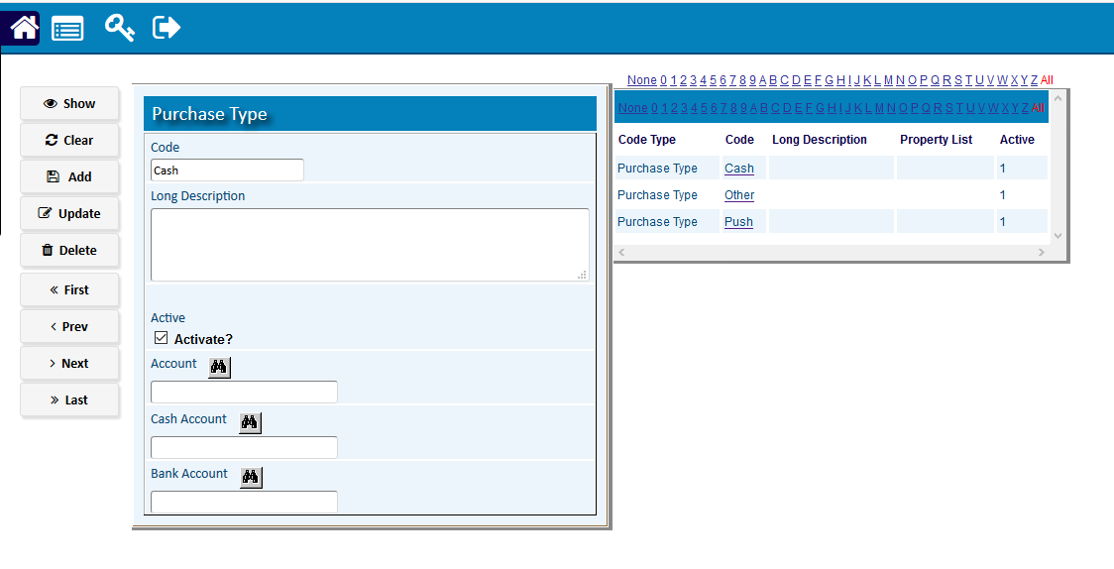

# • [Voucher Entry](http://192.168.1.17:8080/zab/login?screen=acheader&option=Voucher+Entry&menuname=ac)

[Voucher Entry](http://192.168.1.17:8080/zab/login?screen=acheader&option=Voucher+Entry&menuname=ac) Header

|  |  |
| --- | --- |
| **Step 1** | Open System **>** General Accounts **>** Voucher Entry |
| **Step 2** | Choose Transaction Code, Write cheque no. & description |
| **Step 3** | Click **Add** |
| **Result** | New Voucher created |

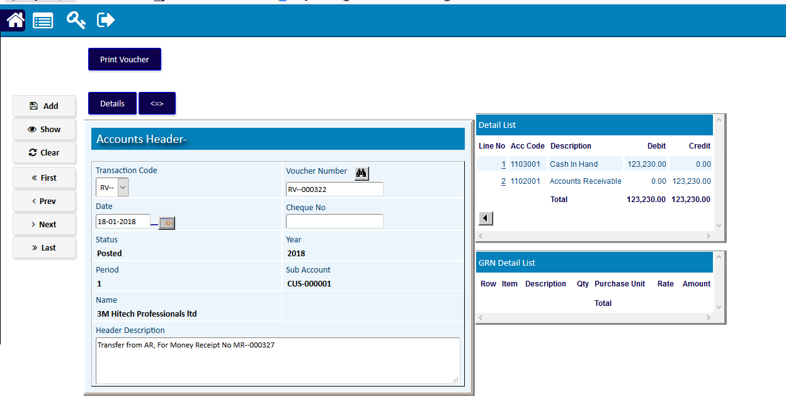

[Voucher Entry](http://192.168.1.17:8080/zab/login?screen=acheader&option=Voucher+Entry&menuname=ac) Detail

|  |  |
| --- | --- |
| **Step 1** | Click **Detail** |
| **Step 2** | Click Detail for selecting Account |
| **Step 3** | Select Department name, Account & write Debit/Credit Amount |
| **Step 4** | Click Add |
| **Step 5** | Repeat Step 2 to 3 for adding multiple |
| **Step 6** | Click **Return** to return to Invoice header |
| **Step 8** | Click **Confirm** to confirm the Invoice. |
| **Note** | Voucher cannot be changed after confirmation. |
| **Result** | Voucher creation complete |

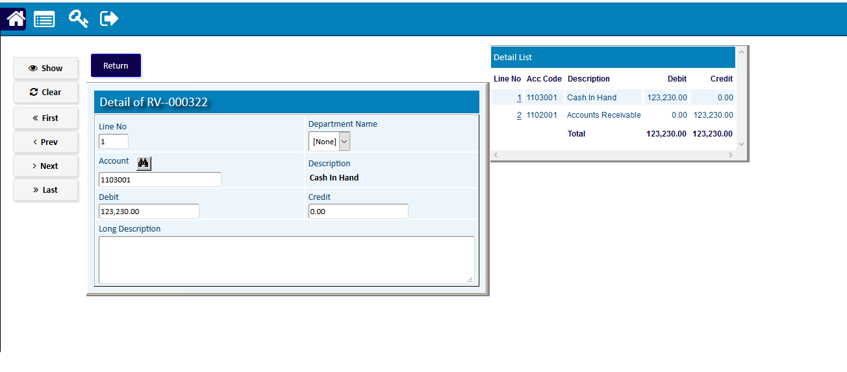

* [**Accounts Receivable**](javascript:run1()&menuname=ar)
  + [Money Receipts and Allocation](http://192.168.1.17:8080/zab/login?screen=arcas&option=Money+Receipts+and+Allocation&menuname=ar)

|  |  |
| --- | --- |
| **Step 1** | Open System **>** General Accounts **>** Accounts Receivable > Money Receipts and Allocation |
| **Step 2** | Choose Customer Code |
| **Step 3** | Click **Add** |
| **Step 4** | Click **Cheque Entry** & choose |
| **Result** | New Money Receipts Allocated |

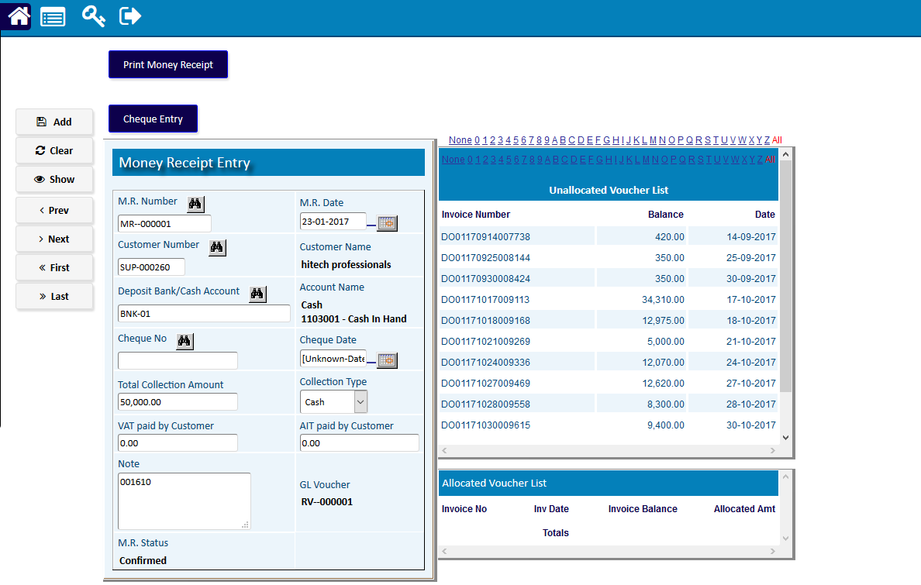

* + [Received Cheque Transaction](http://192.168.1.17:8080/zab/login?screen=arcaschqhon&option=Received+Cheque+Transaction&menuname=ar)

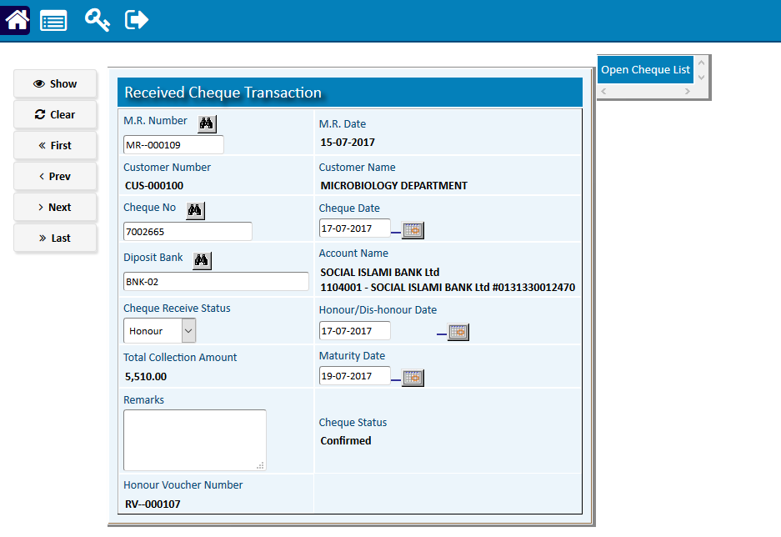

* + [Customer Adjustment](http://192.168.1.17:8080/zab/login?screen=arcasadj&option=Customer+Adjustment&menuname=ar)

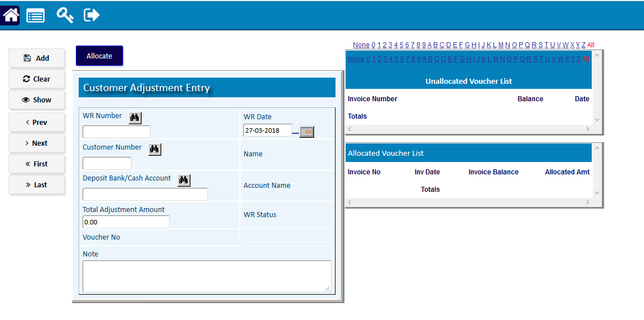

* + [Transactions](http://192.168.1.17:8080/zab/login?screen=arhed&option=Transactions&menuname=ar)

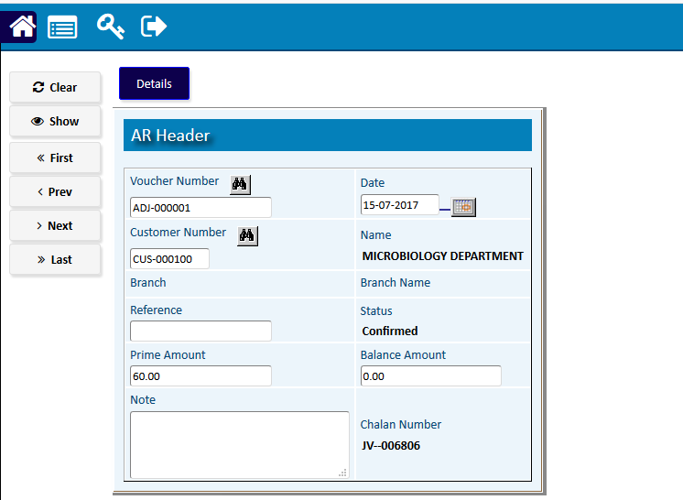

* + [AR Opening Entry](http://192.168.1.17:8080/zab/login?screen=arhedob&option=AR+Opening+Entry&menuname=ar)

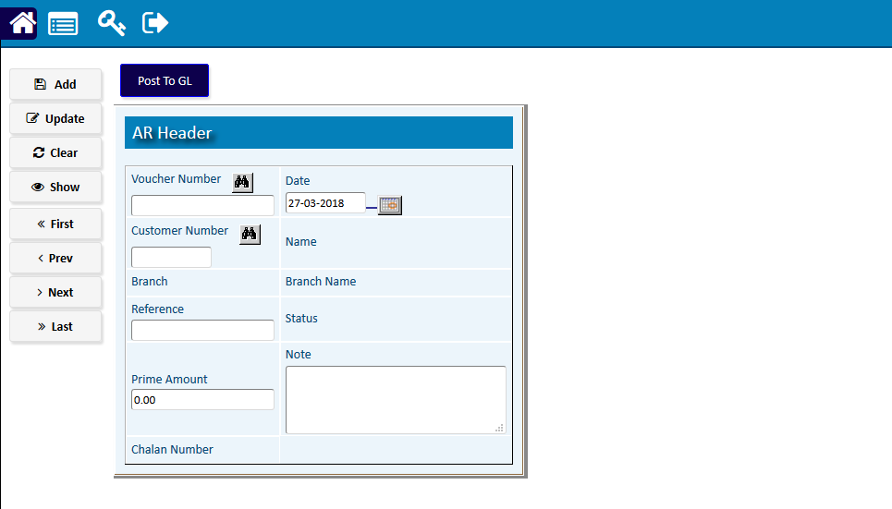

* [**Accounts Payable**](javascript:run1()&menuname=ap)
  + [Supplier Payment and Allocation](http://192.168.1.17:8080/zab/login?screen=appayment&option=Supplier+Payment+and+Allocation&menuname=ap)

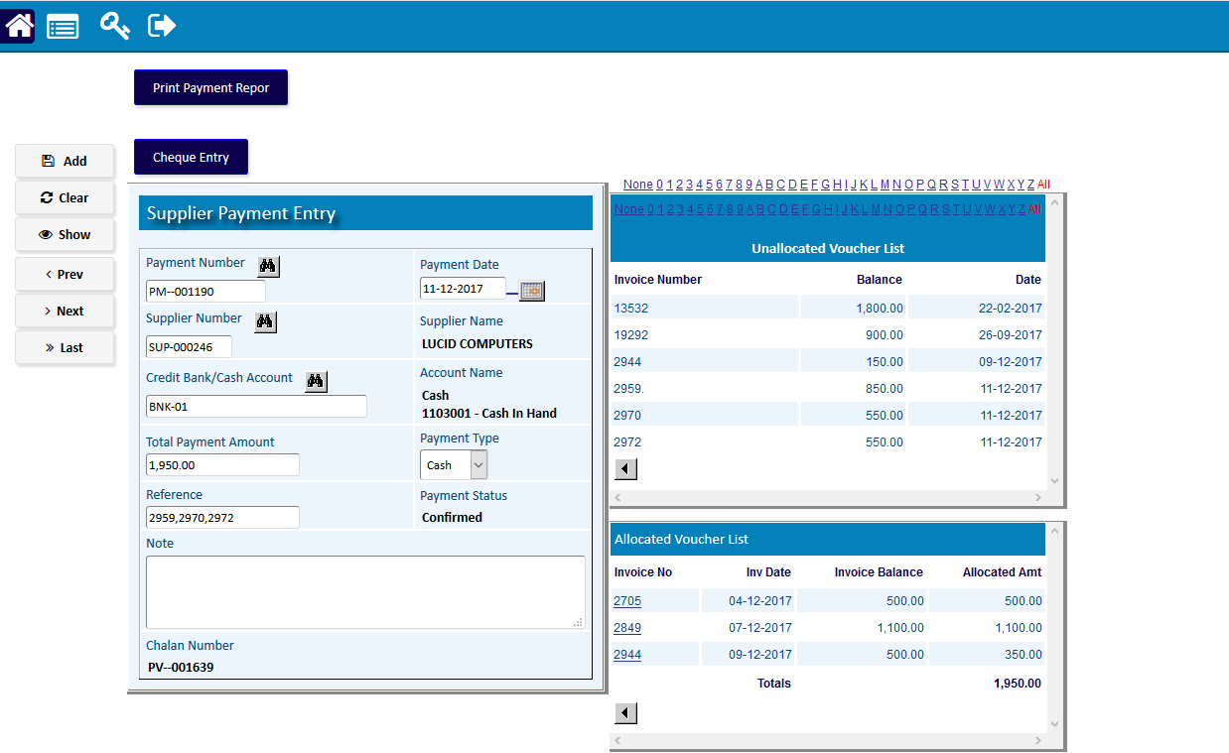

* + [Issued Cheque Transaction](http://192.168.1.17:8080/zab/login?screen=apcaschqhon&option=Issued+Cheque+Transaction&menuname=ap)

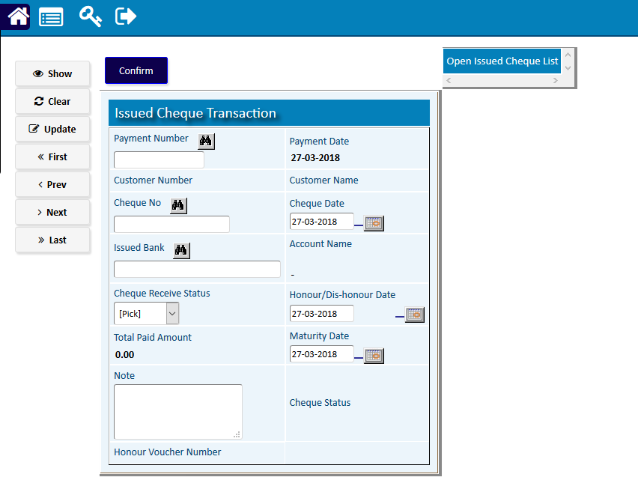

* + [Supplier Adjustment](http://192.168.1.17:8080/zab/login?screen=appaymentadj&option=Supplier+Adjustment&menuname=ap)

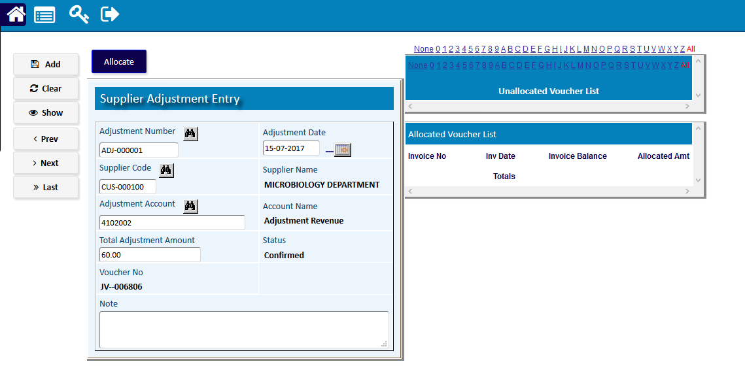

* + [Supplier Invoice](http://192.168.1.17:8080/zab/login?screen=apinvoice&option=Supplier+Invoice&menuname=ap)

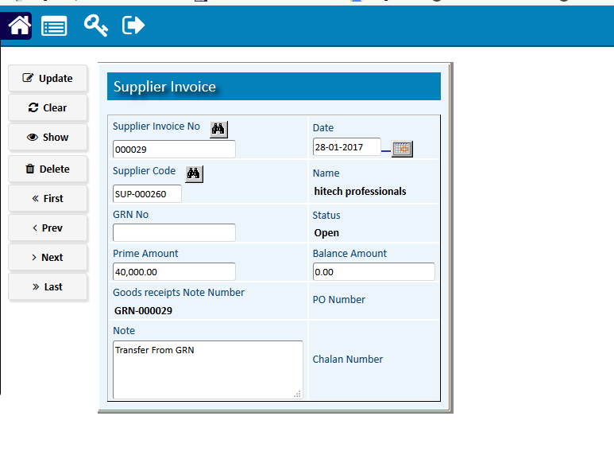

* + [AP Opening Entry](http://192.168.1.17:8080/zab/login?screen=arhedapob&option=AP+Opening+Entry&menuname=ap)

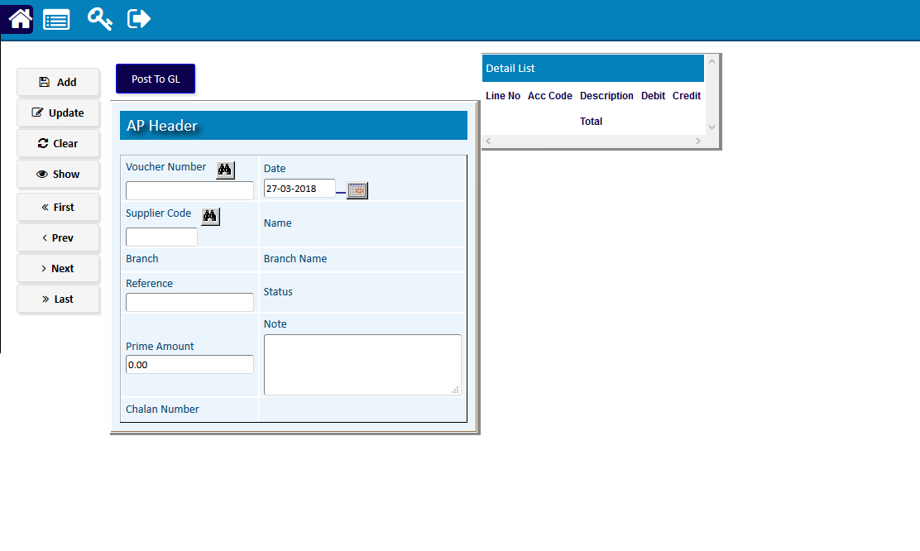

# Reports

## Printing report to preview data

|  |  |  |  |
| --- | --- | --- | --- |
| **Step 1** |  |  | Open System **>** Sales & Invoice **>** Reports |
| **Step 2** |  |  | Select a report option. |
| **Step 3** |  |  | Select the start date, end date & other fields to specify data previewing in the report. |
| **Step 4** |  |  | Click **“View Report”** to preview in print format. |
| **Result** |  |  | The report is previewed in print format. |

